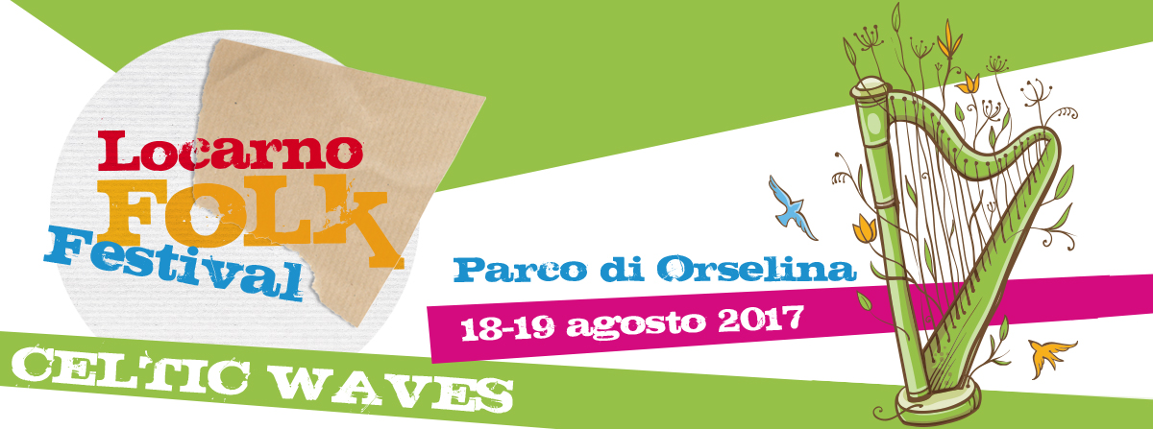
SUBSCRIPTION FORM FOR THE BRETON DANCES WORKSHOP
SATURDAY 19.8. 2017, FROM 16.30-19.00, SALA CONSIGLIO COMUNALE, ORSELINA
LEVEL: BEGINNER / INTERMEDIATE
COST CHF 35 / CHF 25 FOR STUDENTS

Name and surname: __________________________________________________________________
if underage
Name and surname of parent / legal guardian: _____________________________________________
Date of Birth: _______________________________________________________________________
Address: ___________________________________________________________________________
Postcode: __________________________________________________________________________
Tel. / Mobile: ________________________________________________________________________
E-Mail: _____________________________________________________________________________

Regulation: Every participant must be privately insured against injuries and damages caused by third persons. The organizers decline any responsibility for damages or accidents that occur before, during or after the lesson, as in the case of theft of personal objects. The participant consents the publication of photos or recordings on the internet and for advertising reasons.

Upon signing this subscription, I confirm that I have read and accepted the regulations. The subscription is binding and commits the payment of the participation fee.

Place: _____________________________________________________________________________
Signature: __________________________________________________________________________

SEND THE FORM TO: INFO@LOCARNOFOLK.CH OR ASSOCIAZIONE LOCARNOFOLK /
CH – 6600 LOCARNO
THE PARTICIPATION FEE HAS TO BE PAID ON THE SPOT AT THE BEGINNING OF THE COURSE.

